Design Documentation

## Steven Sakayan - 11769641

# Concept Map

# CSS Design

This design is specifically for the resume page, but it allows for great flexibility when creating the other pages in the future. The Content ‘divs’ separate each different section of a page.

* Background
  + Header
    - Logo
    - Nav
  + Content
    - Profile
  + Content
    - Skills Bio
      * Col1
      * Col2
      * Units
  + Content
    - History
  + Footer

# Navigational Map

# Structure Chart

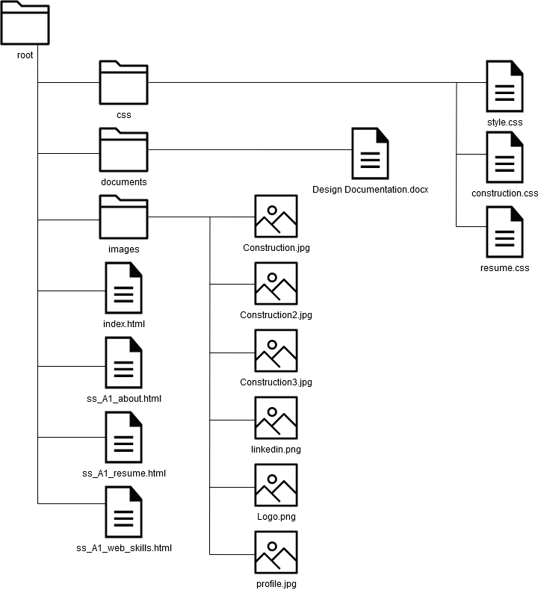

# Storyboards

## Home

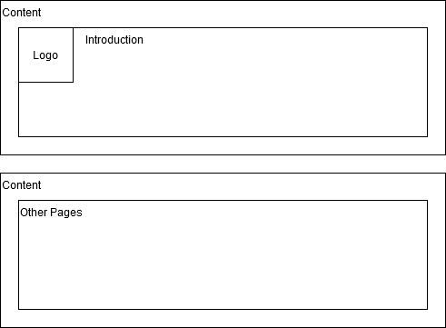

## Resume

## About Me

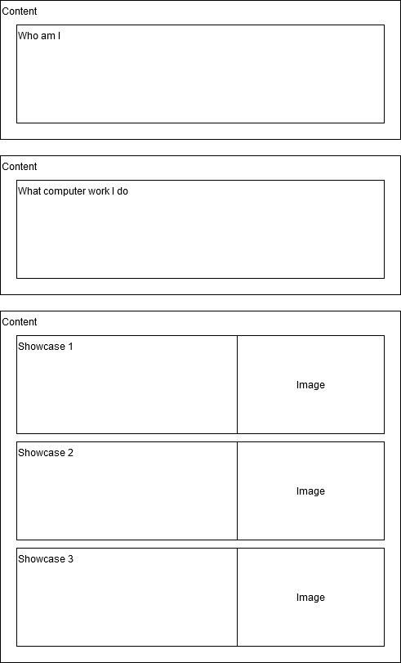

## Web Skills

# Testing Plan

* Validate all HTML and CSS Files (Next Page)
* Test the website on different resolutions including computers and mobile devices
* Test the website on different web browsers
* Test any JavaScript functionality
* Preview the print on every page

# HTML and CSS Validation



